For the spectra before today the B-field value on Keithley was 4.3788V corresponding to about 132.2 G.
03-02-12
We tried to blast Na BEC away at high field in order to enhance NaK molecule lifetime and we see this interesting cloud when the power is kind moderate.
Our guess is that the ring size is given by R = (photon momentum/Mass_Na)*TOF (assuming single scattering)
which kind of makes sense..
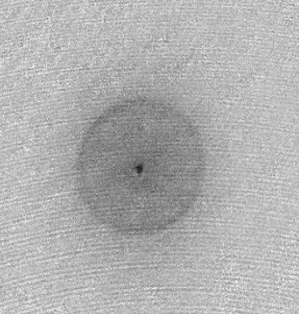

(a) Trying to perform a clean lifetime measurement…

(b) Take spectra at a new field: Keithley Voltage 4.4367V, corresponding to about 134 G
When doing the LZ preparation sweep at high field from +9/2 downwards, we seem to observe enormous losses after the first transfer step to +7/2 half is made. All this happens in the ABSENCE of Na. So it seems there is a likelihood we hit a Potassium Feshbach resonance… what a bad coincidence.

(c) We try a slightly higher fields: Keithley Voltages 4.47V and 4.51V, corresponding to about 135 G and 136 G
Also here we make the observation that after the FIRST transfer step to the +7/2 state we see a very significant loss of 40K (only about 20% left after the RF sweep) So, it seems we have found here a new 40K Feshbach resonance. For us, however, an unpleasant one…
Conclusion: There is a lethal window between about 133 to 137 G…
(d) When going to an even higher field, the 40K loss problem is gone: Keithley Voltage 4.58V, corresponding to about 138.5 G.
To make the search for the RF transitions at different fields easier, we create a standard panel
“K40 check highfield mF prep with SG panel.seq”
With the following mF positions on yCam (xCoord/yCoord):
+9/2 679/304
+7/2 658/291
+5/2 639/286
+3/2 613/271
+1/2 586/259
-1/2 569/253
-3/2 551/232
-5/2 524/228
-7/2 502/213
-9/2 481/205

03-05-12
We used our old scheme to check the stability of the magnetic field (reading on the Keithley). At 138.6G, the reading seems to be stable as we used to have but the bare 40K spectrum doesn’t look as good as before.
First trial:
Second trial after changing the overhead voltage to 7.8V

Third trial after changing the overhead voltage to 8.2V
Forth trial after changing the overhead voltage to 8V

OH MY GODDD!! The source of B field fluctuation is from the Gradient Power Supply (Even the iGBT is always off)!!!! After switching off the gradient power supply we got a beautiful spectrum again:
Okay I am confused now… after turning back on the gradient power supply again we still measured good spectrum
Then now with Na:

Bare 40K spectrum:

03-06-12
We tried out all kind of lock-in parameters to improve the field stability. It turned out that the P-I corner is key parameter for the field stability. We used to use PI Corner= 30Hz and after changing to 1kHz we saw significant improvement by measuring the Rabi oscillation between -3/2 and -5/2 40k states.
OH YA!!
PI Corner 1kHz: With the new relay-switching of the lock (field switches on without feedback, then feedback on IGPY is switched on when the field is high):
Awesome: Even after 3ms we see it oscillate!

03-07-12
Best Rabi oscillation so far
Rabi Frequency = 2kHz
Coherent time = 2ms

Next run: -12dBm
PI corner 1kHz is a bit worse:

Next precision spectrum with pi-pulse on resonance for a 400us, -12dBm square pulse. P-I corner again 3kHz.
- Best spectrum so far

Motivated by our new ability to resolve spectral features down to a 2-3 kHz width (!), we compare the RF spectra with and without Na at the current field of 138.5G. Blue is the atomic peak (sinc, due to square), red in the presence of a almost pure Na condensate.
It seems there is a long wing on the right side… polaron physics???
One issue we have to fix is the offset (about 0.2) on the data with Na condensate, i.e. with low K numbers. Actually, there is also an offset for the higher number, pure K spectrum (here about 0.1). It seems there is a problem with the background subtraction, which kicks particularly strongly in with low K atom numbers (-12dBm).

To investigate on the polaron suspicion a bit more, we also tried doing Rabi oscillations with an almost pure Na BEC and also without any Na atoms. In the presence of a Na BEC, the Rabi oscillation seems to “decay” into unity transfer into the interacting state as the cycle goes on:
(Note due to the background issue, the 0.6 maximum transfer shown for the blue data in the graph actually corresponds to almost 1.0 transfer.)
A possible issue is that when K40 atom number is low (i.e. in the impurity regime), some ncount offset in the m1half image may cause images with perfect transfer to m5half to evaluate to a ratio of < 100%. We’re not sure whether the above blue data maxing out at 0.6 is due to this constant offset or atoms really being only 60% transferred to m1half. Gut feeling is that it’s the first case (constant offset scenario).

Also, we tried taking the FFT of the above data, including the first 20 points where the evolution is still coherent:
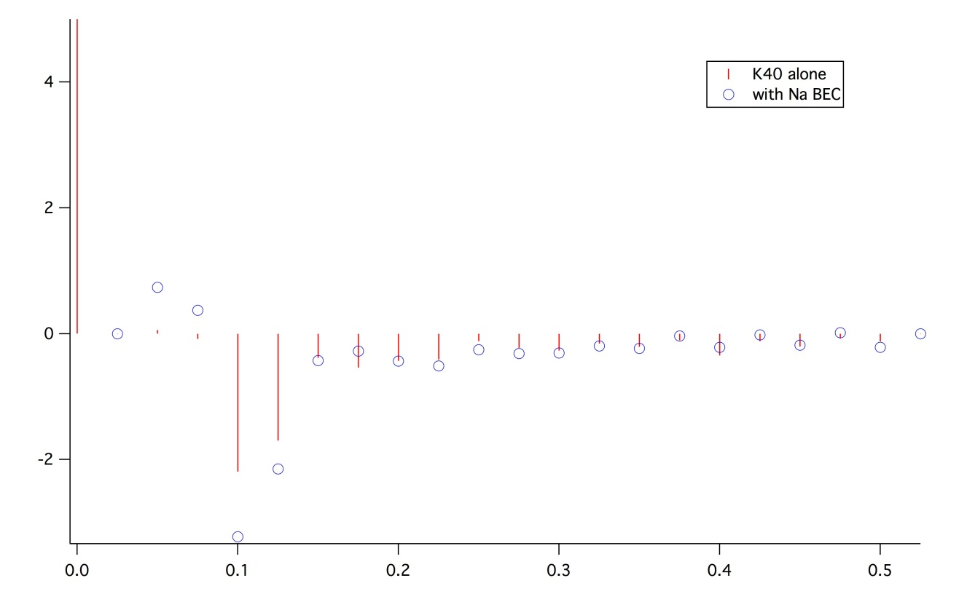

OK. Now I switch to using Blackman pulses to revisit our RF-spectra “polaron” feature. This time, I use a REAL Blackman pulse which Sebastian kindly send to me. With the same rf parameters as the previous spectrum, I obtain the following:
Pure awesomeness. Of course, the “area” under the rf pulse decreases due to the Blackman envelope, so the pulse as it is it’s probably not a 400us pi pulse. I give more power to make it a pi-pulse:

Now, we check out a 40K only Blackman pulse with higher power (-6dBm) to make sure we have higher transfer signal (essentially pi-pulse):
Looks a bit noisy, but note the scale! The 400us blackman has an effective pulse width of maybe 250us, which corresponds to a Fourier width of about 4kHz. We see here indeed a FWHM of about 4kHz, but of course the magnetic field is not infinitely stable ;-) Therefore some additional noise does not come unexpected.

POLARONS!!!
After averaging
Our guess is that the “long tail” on the right is due to the “incoherent” contribution that Dima explains in his notes, and the left peak comes from the “coherent” contribution that’s broadened and extended into the left edge of the incoherent feature.

03/08/2012
With a Gaussian fit to the thermal cloud to guide the eyes:
What’s this?
What’s this?
What’s this?

I also try to fit a double Gaussian to the with BEC data (have in mind two delta contributions – one from the nooverlap K40 atoms and one from the coherent contribution from the polaronic line shape):
Fixing the “nooverlap” contribution frequency to be 37.034MHz,
Does the direction make sense? Do we expect that the polaronic delta contribution will be to the left of the non-polaronic delta contribution? Do we have concern that if we do intrap rf spec. measurements, the polaronic state could decay somewhat?
Today, we can try doing a quick check whether we still have the mean field trapping effect at high fields in m3half compare to other mF states where there are no FB around, compare to no FB m3half atoms, etc.

03/10/12
Keithly Voltage is 4.5858V
The Spectrum in the compressed ODT:
Initially, we tried compressing the CODT to ~0.4V and ~1.5V (about ¾ of capture intensities) before taking the rf spectra in order to squeeze up the condensate density. Here’s what we observe:
What is this?
First of all, the wings on both sides of the withBEC rf-spectra acquires much more weight compared to the decompressed CODT rf-spectra. Interestingly, we don’t see much shift (if at all) of the peak position compared to the bare rf-spectra. I would say the lineshape of the withBEC spectra is still a bit asymmetric with a bit longer tail towards high frequencies.
We noticed that K40 m5half in-trap images after compression sees the m1half spin state due to high densities. This is enhanced in the presence of a healthy Na BEC. Without a condensate, K40 m5half images rarely have the white/black stripes even if the actual atom numbers are higher compared to withBEC K40 atom numbers. This gives us a hint that the mean-field potential induced by Na BEC does suck in (at least) m1half atoms. We should still try to confirm that the m3half atoms are sucked in as well. In any case, we should give some time of flight before taking images and make sure the focus is properly adjusted to minimize this light scattering.

Also, we tried using very high RF power (16dBm higher ~2^5 times more power; ~5.7 times higher rabi freq) with the compressed CODT to take some rf-spectra. Here’s what we observe:
From now on, we should try to give enough TOF to reduce the K40 density before taking images so that the overall base line is well defined. Don’t forget to tweak the imaging focus after changing TOF!!!

03-11-12
ODT trapping frequency measurement with Na:
Both ODTs are at 0.2V

03-12-12
Trapping Frequency Measurement by kicking (the data are all averaged over three runs) :
Measuring x trapping frequency from the y-camera:
Plug ODT 0.4V
Computer ODT 1.5V

Na

Comparing 40K and 23Na trapping frequencies :
f_Na/f_K = sqrt(alpha_Na/alpha_K)*sqrt(m_K/m_na) = 0.817
and experimentally we measured
f_Na/f_K = 0.809
Two values are agreed within 1%

Plug ODT 0.2V
Computer ODT 0.75V

Na

Plug ODT 0.2V
Computer ODT 0.2V

Na
Na
It seems that we have +2mV constant offset in the plug ODT feedback photodiode
03-13-12
Measuring y trapping frequency from the z-camera:

Measuring z trapping frequency from the y-camera:

For the following graphs we changed the kick method by ramping the magtrap to 0.1V in 50ms and suddenly switching off. We also turned on the Bz bias to make sure the gradient is mostly in the z direction.

Real DOT Power v.s. Control Voltage

Summary of Trapping Frequencies (Na):

(f_x)^2 = -34.4+14530*V_ComputerOdt
(f_y)^2= -1031+96626*V_PlugOdt

(f_z)^2= 1.24*(f_x)^2+0.92*(f_y)^2
f_z is obtained from the oscillation measurement by kicking atoms in the z direction.
The outlier is when plug odt = 0.2 V and computer odt = 0.3V. At this point gravity has significantly deformed the trap in the z direction. It make sense that the scaling rule can’t be applied here.

Sodium Trapping Frequency Table:
Plug ODT Voltage | Computer ODT Voltage | fx | fy | fz | fbar
0.2 | 0.2 | 53.59 | 135.3 | 142.8 | 101.2
0.4 | 0.6 | 93.19 | 194 | 213 | 156.7
0.6 | 0.8 | 107.7 | 238.6 | 258.4 | 187.9
0.8 | 1.2 | 131.9 | 276.2 | 302.9 | 222.6
1 | 1.6 | 152.4 | 309.2 | 341.7 | 252.5
1.2 | 2 | 170.4 | 339 | 376.5 | 279.1

Potassium Trapping Frequency Table:
Plug ODT Voltage | Computer ODT Voltage | fx | fy | fz | fbar
0.2 | 0.2 | 65.38 | 165 | 174.2 | 123.4
0.4 | 0.6 | 113.7 | 236.6 | 259.9 | 191.2
0.6 | 0.8 | 131.3 | 291.1 | 315.2 | 229.3
0.8 | 1.2 | 160.9 | 336.9 | 369.5 | 271.6
1 | 1.6 | 185.9 | 377.2 | 416.8 | 308
1.2 | 2 | 207.9 | 413.6 | 459.3 | 340.5

The fz in the red box might have 10% error due to gravitiy

Summary of Magnifications
Each Pixel is 8.71 um

Each Pixel is 1.92 um
In order to measure the magnification of z camera, we perform a x kick by field gradient on atoms and measure on both z and y cameras.

- 15.13 pixels in Ycam = 13.97 pixels in Zcam
- Each Pixel in Zcam is 2.08um (40K)

March 15, 2012
Working on the two step preparation scheme
(a) Stern-Gerlach at low field: Sweep from 3.2MHz (-16dBm) within 10ms to
Positions: State:
564/260 +1/2
497/262 -1/2 that’s our guy
427/264 -3/2
357/270 -5/2
289/269 -7/2
220/276 -9/2

(b) Feshbach field and preparation of -3/2 state
[We play a little bit around with moving the jump to the Feshbach field into the ODT evaporation: This might save some (precisious) time and consequently lead to somewhat higher atom numbers, if the evaporation efficiency in the (1,1) and (92,-12) spin combination is still good.
Indeed, it seems we see slightly better atom number. However, we still resort to switching on the Feshbach field after completed evaporation to have the same starting conditions before the molecule conversion sequence and no dependence of the evaporation on the respective (fixed) Feshbach field.
Nevertheless, whenever we may be short in atom number ]

zCam focusing position:
18.46mm

03-16-12
Molecular Spectrum at 133.9G
Finally, We are able to resolve the molecular peak (Note: the measurement was done without Na BEC)

After averaging:

Interestingly, we still observed significant broadening without the existence of condensate.
*35.998MHz corresponds to 133.9G

New Field Calibration around 130G:
03-18-12
Molecular Spectrum at 129G
(Keithley 4.269V, Ctrl Voltage 4.385V)
General parameters for the spectra:
ODT: computer 0.2V, plug 0.2V rather cold clouds, fluffy
RF power: +20dBm
(b) Transfer ratio versus RF pulse duration:
Sitting on top of the molecular feature at 34.971 MHz we measure the transfer ratio versus RF pulse duration (real blackman pulse) with power +23dBm.

Varying the RF pulse duration up to 3ms we seem to see a continuous increase of the transfer ratio. However, this increase may be a little bit “fake”: Visually, we have the impression that the amount of -3/2 atoms goes down, while the amount of detected -5/2 atoms stays approximately constant. So it seems, instead of having a finite lifetime of the (molecular?) -5/2 atoms, we seem to have a finite lifetime of the -3/2 atoms… What could be the reason for that?
Based on this measurement, we decide to choose a pulse duration of 1.2ms at +23dBm for the following spectra

(c) Detailed spectrum with thermal Na

(d) Detailed spectrum of bare atomic 40K
(e) Lifetime of -5/2 atoms after transfer:
We sit at the atomic resonance at 34.870MHz and introduce a hold time in the (shallow) dipole trap
- This data looks quite noisy and it would be very tedious to take a lot of lifetime data under these conditions: Too much averaging would be required.
- However, an alternative method might heavily reduce the noise: Preparation of a 50/50 superposition/mixture of the -3/2 and -5/2 spin state. Since -3/2 is expected to live very long, the transfer ratio should be solely determined by the lifetime of the -5/2 atoms. So, this promises to offer a nice common mode rejection of fluctuations in the overall atom number!

03-19-12
Molecular Spectrum at 123G
This time we look at the loss spectrum, since we don’t expect to see the molecules directly.
Here we already try out the common mode rejection scheme: Initially a superposition of -1/2 and -3/2 is prepared. Then 20kHz sweeps are made, that may transfer atoms into -5/2 appearing as “loss” in the atom number ratio of -1/2 and -3/2.
(a) Loss spectrum with thermal Na cloud:
(b) “Loss” spectrum on the bare 40K atoms:
NOTE: In the above (and in all previous) loss spectra, the frequency axis shows the start frequency of the sweeps. We actually should instead put the center frequency of the sweep on this axis. It is the more natural way of displaying the data.
- UPDATE ALL GRAPHS THAT ARE AFFECTED!

(c) Molecule transition with 50 ms pulses:
Being a bit concerned about the “accuracy” of the absolute peak position in the sweep scheme, we also record the molecular feater using a 50 ms, 5 dBm pulse instead:
Compared top (a) the feature appears shifted by about the 10kHz that we expect, when changing the frequency axis from “sweep start” to “sweep center”.
Another nice point on the binding energy plot
(d) New field: 130.422 G, expected binding energy about 60 kHz
We did initial preparations to work at this field (Keithley 4.318(1) V). However, it seems to be at the center of the deadly 5G zone with the -3/2 + Na Fehsbach resonance.
We try to minimize the hold time in the -3/2 state by doing a pi-pulse for the -1/2 <-> -3/2 transfers. It might enable us, to measure a binding energy spectrum. However, to do efficiency or lifetime measurements it might not be the best point.

03-21-2012
Molecular Spectrum at 129.5G
NEW FIELD : Keithley = 4.2850V, setV = 4.4V
(a) Bare Atomic Transition:
(b) A wonderful RF spectrum:

(c) Binding Energy Curve:
NEW FIELD : Keithley = 4.2850V, setV = 4.4V
(d) Some efficiency measurements:
(i) Doing a 10kHz sweep across the molecular feature and vary the time of that sweep:
- Almost flat, maybe some increase of signal for longer sweep…
(NOTE: In light of the later finding on March 23, the slight increase of signal in the -5/2 state is most likely due to atoms and not molecules)
(ii) In order not to take too long, we pick a sweep time of 2ms. Here we try to figure out, which span for the sweep yields the best conversion efficiency:
- Pretty clearly peaked for a 4kHz wide span …

(iii) Conversion fraction vs Na loading time:
It seems we get an increasing molecule conversion efficiency the more Na we load. But this does not mean that the total number of molecules actually goes up!
Note: Conversion fraction being high does not necessarily mean that absolute molecule number is high; all of the plots should also contain total molecule number vs. scan parameter
UPDATE ALL GRAPHS!!!
(iv) Finally, conversion fraction versus ODT power (CODT control voltage):
- The conversion efficiency seems to increase for higher compression (however, we are not sure if the increase in -5/2 is only molecules… see below). Although the adiabatic compression should not change the phase-space densities, it might be that the improvement of overlap/ suppression of sag leads to a better conversion…!?

03-22-2012
Lifetime measurement on bare transition at 129.5G:
We load about 3.6 sec of Na and cool down to CODT = PODT = 0.2V. We do an imperfect LZ sweep into m5half, so that we can normalize the m5half number using m3half number (which gets transferred to m1half right before imaging).
- Turns out, the “common mode” rejection of the atom number noise due to having the -3/2 atoms to normalize to, works nicely!
- Important note: We also see that the atom number in the -3/2 state stays essentially constant even for long hold times! (see IGOR files)
The Na number fluctuated quite a bit for the above data taking session, so we decided to tweak the lasers a bit and retake. For this run, we also compress the ODT a little bit after cooling, hoping that the Na number will be more stably maintained during hold time (after ODT cooling, ODT ramp up in 500ms to CODT = 0.4V and PODT = 0.22V):

Fitting a double exponential gives two decay times:
tau1 = 25 (pm 13) msec
tau2 = 304 (pm 91) msec
(Note : I fix the constant offset to be zero to reduce fit parameters)
We tried to do the same measurement with molecules:

- Big QUESTION: So what we see after more than 100ms holdtime, it that really molecules???
We have to figure out a way, how to do this measurement even cleaner!

03-23-12
Lifetime Measurements
Today’s goal was to achieve a clean lifetime measurement of the NaK Feshbach molecules. We implemented the RF pulse from m5half state m7half state by adding one more Agilent and fast RF switched.
(i) New setup of RF switches and additional Agilent
TTL: Agi1
fast RF switch
TTL: RF1

fast RF switch
TTL: Agi2

fast RF switch

experiment

Note the “feed-in-backward” strategy to make sure, we don’t dump the RF in the switches internally.
(ii) First signal of molecules in the -7/2 state (everything still at magnetic field 129.5 G - Keithley = 4.2850V - setV = 4.4V)
Molecular Signal in the -7/2 state (gray scale 0.7-1.3):
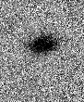

At this field the molecular binding energy is 89 kHz (see above).
We observe that we can selectively transfer the atoms and molecules from the -5/2 state to the -7/2 state. We actually do a plus/minus 4 kHz sweep across the molecular feature within 1ms, using the same parameters as for the association of the molecules.
If we try to transfer atoms in the “gap” between the atomic and the molecular feature, we see NO transfer, as expected.
NOTE: We realized that we have to introduce a wait time of about 100us after the RF transfer to -7/2 in order to make sure that all RF switches are in place to do the -3/2 to -1/2 sweep. (At first we did not see any atoms on the -1/2 image, which was quite puzzling. However, it was clear that the atoms could not have just vanished :D )

(iii) Dissociation spectrum from -5/2 to -7/2 (-5dBm, 1.2ms real blackman pulse to avoid side lobes)
In order to understand the details of the transfer between -5/2 and -7/2 states, we record a dissociation spectrum. The dissociation pulse is performed right after association.

On this spectrum (transfer normalized to the number of remaining –3/2 atoms) we observe a beautiful baseline for frequencies above 33.35 MHz. That is a clear strength of this new method – in addition to the improved signal strength.
However, we haven’t yet analyzed carefully, if we perform a full transfer of the molecules from -5/2 state to -7/2 state. To be done (should be easy with simultaneous triple imaging on -7/2 , -5/2 and -1/2)
We see a wonderful tail to the left, as expected for a dissociation spectrum into a lower lying spin state.

(vi) NaK molecular lifetime measured via dissociation:
We introduce a hold time between association and dissociation and plot -7/2 population divided by-7/2 plus -1/2 population:
The y axis is the ratio between 40k m7half and m1half states -> (m7half/(m7half+m1hlaf)
NOTE: We have used the old fudge factor of 1.5 to compensate for the imaging efficiency on -5/2 and -1/2 K images. However, for imaging of the -7/2 the fudge factor should be even larger. The 30% ratio at zero hold time is a bit too optimistic.
However: The lifetime extracted here is actually quite conservative, since the hold time on the x-axis is actually the time between the association and dissociation sweeps. The finite length (1.2ms) of those is not taken into account. Probably, it would be justified to add two times half the sweep duration to the lifetime, yielding 4.2 ms. Quite impressive!
When introducing a ridiculous hold time of 100ms, we observe no molecules anymore. This clarifies yesterday’s measurement. When performing the sweep to -7/2 on the atomic transition, we observe a number of transferred atoms. With this we confirm that the finite signal that we had in the -5/2 state after several 100’s of ms in earlier measurements was actually NOT molecular signal. Instead, we seem to face a decay mechanism that destroys the molecules, but leaves the “debris” in the trap…
What could that be? Possibly a lifetime measurement at different magnetic fields can give us hints. E.g. at 4 or 5 different fields with binding energies of say, 400 kHz, 200 kHz, 100kHz, 50 kHz (for lower binding energies might actually be hard to implement the association sweeps safely…)
We will also find out if Na and K leftover atoms play a role in this process, when we take lifetime measurements after blowing away excess atoms.
NOTE: We need to redo the efficiency measurements with the background-free detection of molecules. Only this allows us to detect REAL efficiency!

(v) Try Sodium purification via dipole trap
On principle we expect that it should be possible to kick out Na of the dipole trap simply by lowering it: Of the three “species” Na, K and NaK pure sodium is expected to clearly have the highest lying trap bottom.
A quick calculation for a crossed dipole trap at 1064nm with w0 = 120um beam waist, the trap bottom (and actually gravitational sag) behave as follows:

When trying to lower the dipole trap within 2ms, we actually seem to loose the molecules quickly. Of course, the for Na the lower dipole trap at the end means only a little bit more time of flight in the image. Maybe we have to tweak a little bit more… ;-) It would be so nice and simple if it worked.
So, actually this should work… Do we possibly have a magnetic field gradient or curvature that drags out the NaK molecules preferentially…

03-26-12
Some sanity checks on the setup due to concerns that noise could actually split up the molecules at 80 kHz binding energy:
- Checking for noise on the VCOs regulating the dipole trap AOMs. We see the frequency of the VCOs (center about 78 MHz and 82 MHz) shake within about 10 kHz, but we do not see clear side bands at 80kHz or anything clearly suspicious… So, not too much worries here.
- Checking for noise on the error signal of the magnetic field stabilization (New Focus lock box). Also here nothing being obviously bad.
Some technical measurements for the molecule paper
(i) K Atom number calibration for on zCam
Already on March 14 we determined the pixel size for K images:
yCam: 8.71 um / pixel (demag)
yCam: 1.92 um / pixel (mag)
zCam: 2.08 um / pixel
Now we determine the “fudge factors” for the scattering cross sections at high field. We record several shots of pure 40K in the +9/2 and the -9/2 state on yCam.
While making sure that the length of the sequence does not change, we take series of images at high field on the zCam. By comparing the Ncount of all series, we are able to extract the fudge factors with respect to y-imaging and consequently we know the total atom number.
We still work at the magnetic field 129.5 G - Keithley = 4.2850V - setV = 4.4V. The Tandem-Frequencies for imaging the different spin states are:
-1/2 204.5 MHz
-3/2 220.5 MHz
-5/2 231.5 MHz
-7/2 244 MHz
-9/2 255.5 MHz
Low field: -9/2 247.5 MHz
We take several images of pure 40K under identical conditions – just in the different spin states.
The (preliminary) fudge factors between the spin states are as follows:
zCam
mF: fudge factor for cross section:
-1/2
about 1.5
-3/2
about 1 (!)
-5/2
about 2
-7/2
about 2.5
-9/2
about 1.5
-9/2 (highfield) +9/2 (lowfield)

+9/2 (lowfield) +9/2 (FB field pulsed on, then lowfield)
about 1
So, gradients due to the FB field do not drag atoms out of the trap!

yCam
about 1
+9/2 (lowfield) -9/2 (lowfield)
So, yCam is “internally” also fully consistent!

Connection between yCam and zCam:
about 1
-9/2 zCam (highfield) yCam (lowfield)
about 1.5
+9/2 zCam (lowfield) yCam (lowfield)
- Everything seems consistent More accurate numbers to be evaluated!

03-27-12
Time-of-flight expansion of K/Na atoms and NaK molecuels
TOF 1 ms 2 ms 3ms 4 ms 5 ms
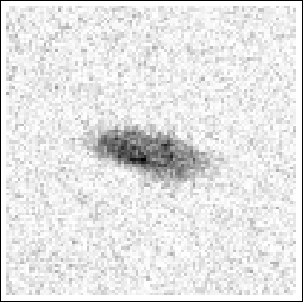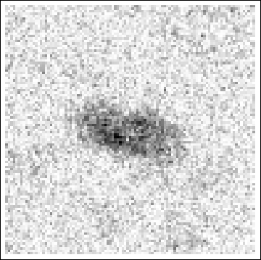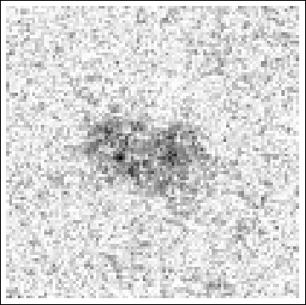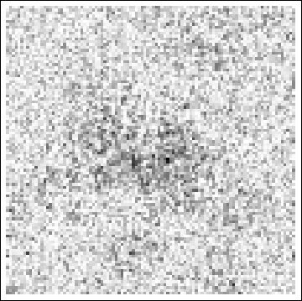
Molecules
(sum of 10 img)

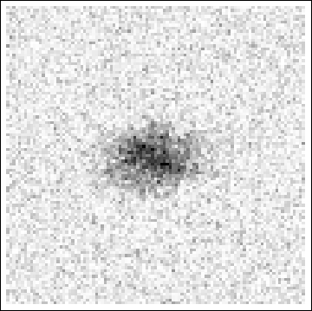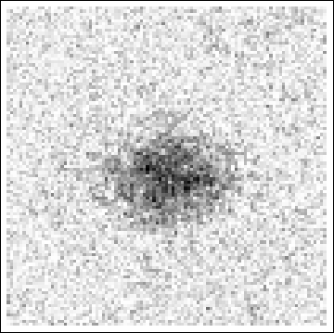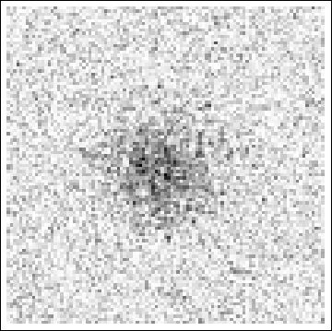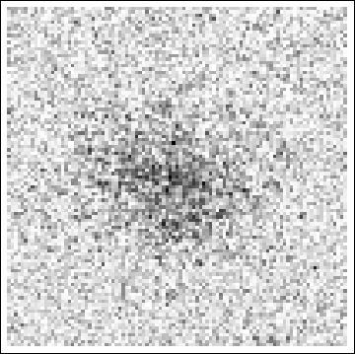
Atoms
(sum of 4 img)

Finding the trap bottoms
(i) Trap bottom with the Na condensate:
CODT: 0.2 V PODT: 0.205 – 0.21
(ii) Trap bottom with K atoms:
CODT: 0.2 V PODT: 0.165
(NOTE: PODT is the strong ODT!)
- So, going to 0.2/0.19V in the dipole trap control voltages should actually do the job!
BEC position on yCam after 7.1ms: 555/262

Lifetime measurements with ODT rampdown
We try to see if a careful, fast rampdown of the ODT, which releases Na early, can help to increase the molecule lifetime. To this end we rampdown the ODT right after molecules conversion to
CODT: 0.2 V PODT: 0.18
At these levels the molecules are still happy and the Na atoms slowly, but surely leave the trap.
We record lifetime curves without the rampdown, with 3ms rampdown and with 0.1ms rampdown. The molecules are detected after dissociations into -7/2 state.
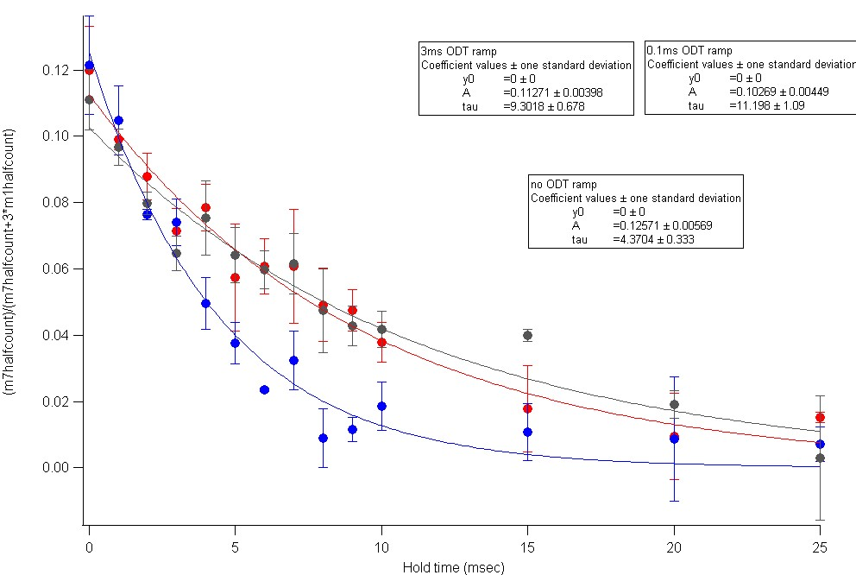
- WOW, so we actually see an improvement of lifetime by a factor of more than 2
So, we see, it is better when Na is gone earlier. However, there might still be room for improvement, because Na atoms actually do not leave the trap fast… Note, that at the trap bottom the combined potential of gravity and dipole trap only is a plateau, i.e. the force that acts on the atoms is only around zero! To do the clean-out even faster, probably the only method is RF pulses to different mF states or hyperfine levels and then: resonant light!

03-28-12
Optimizations:
- Realigning dipole trap (one beam down by about 100um!)
- Trap bottom went clearly up Small shift of magnetic fields (about 20mG)
- Features in RF spectra shifted a bit
- Re-focussing was essential (black/white cross)
- Turned out: After RF switches changes (3 days ago) much more RF power at position of the atoms!

03-29-12
After the changing the switch configuration, we have almost 20dBm more power than before

Our Old power is way too much

Very crucial finding: It seems that high RF power can shift the magnetic field upwards.

We integrate two new RF pulse to 40K -3/2 -> -5/2 and Na (1,1) -> (1,0).
Now we have five independent RF pulses and five switches.
A nasty finding: if one uses the switches in the reverse way, the switch can shot itself off beyond 22dBm.

03-30-12
(a) MPB laser fixed: Increase of P-Gain in the PID regulation… now operates nicely in power stabilized mode.
(b) Installation of DL Pro as 40K master laser.
- Lock via old lock box, however, scan is provided by Toptica Scan Module, covering up to tens of GHz. Makes scan control on lock box quite sensitive, but nothing serious.
- Laser operates at 128mAmps and 20 degree Celsius
- NOTE: The way the spectroscopy is set up currently, the EOM sidebands are modulated on the “complete” laser beam. After the cube that goes to the fiber, there should be no sidebands visible due to polarization selectivity. However, there is a risk of having some sidebands on the master laser beam… maybe we can change this at some point!
- We see very nice numbers of the 40K MOT fluorescence. Even the worst shots were better than the old benchmark image However, we have still some fluctuations on the time scale of several minutes on the atom number. It smells like fiber polarization issues. We should check for the input polarizations and the temperature sensitivity of the fiber splitter.

K40 m5half to m7half bare transition with a 2ms 0dBm sweep:
AHHHHHHH!
Finally, I managed to get a disassociation spectrum from m5half to m7half. This spectrum actually shows not only the molecular transition, but also the bare transition, which I assume, comes from the broken molecules:
Averaged spectrum looks nice:
Now I set the disassociation sweep to have 2ms length with 0dBm power from 33.35MHz to 33.2MHz.
This should give me clouds that roughly look like this (both images on a scale of 0.5 to 1.3; raw images are also saved as reference):
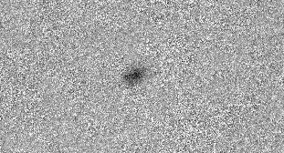m7half after disassociation 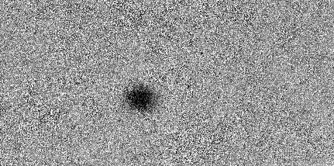m1half after disassociation
I noticed that you really need 500us to switch the “fast switches” which are chained together… odd… I thought these were ns fast… For instance, to switch off Agi_rf fast switch and switch on Agi_gaussian fast switch, I must give 500us in between time.
Now, let’s flip the m3half bare atoms into m5half and compare the lifetime with and without this procedure:
Okay. I was about to take this lifetime curve, but after setting up all the agilants and the relevant frequencies, I noticed that the m5half atoms scattering off m7half resonant light completely swamps the dis-associated m7half molecule signal. On top of the usual number fluctuation we have, it’s going to be very hard to extract reliable numbers using this way. Perhaps, we should now try to blow away K40 atoms once putting them into the F=7/2 manifold.

Things to be done:
- Try to do Na 1,1->1,0 and take lifetime curve; compare lifetime of molecules with and without doing this cleanup
- Try to get rid of remaining K40 atoms

Okay. It’s 8AM now, and I go home!
On a side note, the IR amplifier keeps switching off. Just today, it switched off more than 5 times. Also, the K40 repumper TA occasionally switches off. This happened thrice today.

04-02-2012
We observe that RF switches (ZASWA-2-50DR+) add (depending on the power) enormous side bands to the RF, perfect higher harmonics.
- This explains our problems with the spectra. In the old configuration of switches we did not reach the power levels that are “needed” to see the enormous side bands.
We furthermore observed that we must not have any DC offset on the Agilents because then the problem of higher harmonics is even much stronger….
In any case, it should help to put an appropriate low pass filter (e.g. 48 MHz) after the chain of switches to suppress the higher harmonics.
(Important side note: The switches can be used in regular or reversed arrangement (i.e. from one input to two outputs or form two ))
Order of RF-Switches
Amplifier
Last switch: Agilent 2
Next: RF 1
Next: Agilent
Next: RF pulse
Next: Rhode-Schwartz

Note: the output power difference between Agilent2 and RS is 5dB
Maximum power one should apply on Agilent2 is 3dBm and RS is 8dBm. This is due to the fact that the RF amplifier reaches saturation anyways at these levels. So, no additional RF power is gained by going to larger amplitudes at the frequency generators! Only the problem with higher harmonics increases for higher powers…
Test 1: 35 MHz, 13dBm, after Switch chain, without amplifier, observed with Agilent Spectrum Analyzer.
We also noticed 60KHz, 120KHz, 180kHz noise from the 30W RF amplifier. Power level is around -28dBm. This might be a possible reason for the (relatively fast) decay of molecules into atoms (that do not leave the trap!).
(i) If going through one switch (Agilent 2): First higher harmonic suppressed by 40dB
(ii) If going through five switches (R & S): ): First higher harmonic suppressed by 28dB. With 1Volt DC offset: ONLY 10dB suppression of first harmonic!!!
Test 2: 35 MHz, 13dBm, after switch chain, with amplifier, observed with Agilent Spectrum Analyzer.
- The higher harmonics seem to be slightly suppressed compared to test 1, by additional 2dB or so. Probably the RF amp is more efficient for lower freq. So, no additional badness through the amp

NOTE: The line width of the RF is not visibly increasing after the switch chain or the amplifier. Using the spectrum analyzer it appears to be clearly below 100Hz. So, no risk that a broadening of the frequency covers the molecule binding energy.

Lessons learned: Let’s make sure the most important RF pulse (now: molecule association) is going through ONLY ONE RF switch in order to minimize the side effects!

@Shifts in spectra: It might actually be that the shifts in the above RF spectra originate from a finite DC offset on the Agilents. This is likely to result in a large enough shift (few tens of mG) of the DC magnetic field…

